Led team of 7 engineers, managing deliverables, training, an d project execution


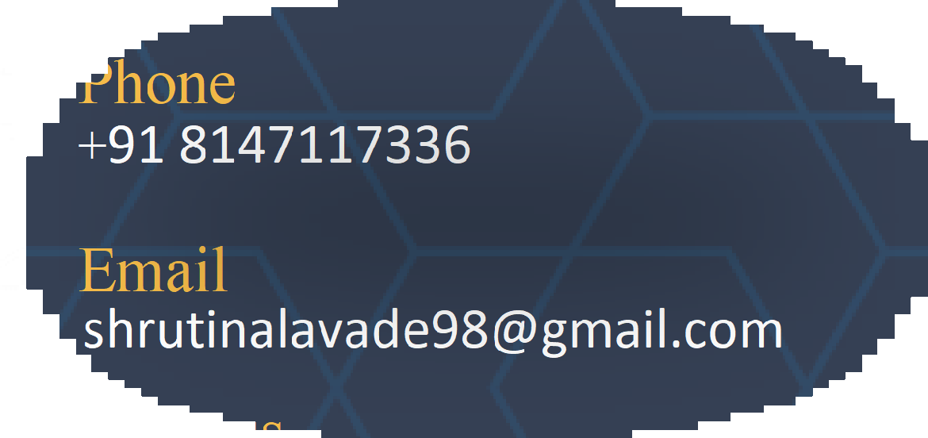
Shruti Nalavade
Detail-oriented medical Labelling Specialist with 7+ years of experience in designing, developing, and maintaining compliant labelling solutions for class I-III medical devices. Skilled in aligning labelling and IFU content with global regulatory standards including EU MDR, FDA, ISO 13485, ISO 15223 and ISO 20417. Proven ability to manage end to end labelling lifecycle – from gap assessments and remediations to change control and regulatory documentation updates

WORKEXPERIENCE

Tata Elxsi – Labelling Specialist

Medical Device Labeling

Sep 2018 – May 2026
Phone
+91 8147117336
Email
shrutinalavade98@gmail.com
Address
Belgaum, Karnataka


- Managed end to end medical device labeling process, from creation and artwork development to regulatory compliance and release
- Data Mining: Extracted and consolidated technical files, product labels, IFUs (Instructions for Use), and packaging components
- Gap analysis: Assessed EU MDD vs EU MDR/US FDA requirements, identifying compliance gaps.
- Label updates: Created redlines of labels to align with MDR, IVDR, and FDA standards.
- Artwork creation: Designed labels in Adobe Illustrator compliant with regulations and standards
- Labelling plans: Led creation and execution of product labeling plans for US/EU compliance.
- Cross-functional collaboration: Partnered with Regulatory, R&D, Ops, and Marketing to ensure accuracy.
- Change control: Managed RCHs/PCHs in Agile PLM for label updates and approvals.
- Regulatory response: Addressed Notified Body comments with corrective updates.
- Translation support: Coordinated with translation teams for global labelling execution.
- 3D CAD Model Review: Conducted detailed analysis and validation of CAD models to ensure accuracy and compliance with medical device packaging and labeling requirements
- Proofreading of labels using the Global Vision tool involves automated text, artwork, and barcode verification to ensure compliance and accuracy. It detects errors, validates layouts, and confirms UDI barcodes meet ISO/IEC standards before label release
- Strong understanding of labeling software (e.g., Loftware, BarTender, Adobe Illustrator, Label Vision, Global Vision)
- Ability to analyze technical issues, identify root causes, and implement effective solutions.
- Executed systematic updates a ross all label template libraries to replace legacy branding with updated company logos and text elements
c

Project Management
- Led team of 7 engineers, managing deliverables, training, and project execution.
- Planned projects with the Project Manager, including effort/cost estimation and documentation.
- Improved efficiency by conducting regulatory workflow training, reducing onboarding time.
- Showcased skills in problem-solving, detail orientation, and cross-functional collaboration under deadlines

EDUCATION

BE, Electronics and Communication - 2018
Aggregate – 72%
Gogte Institute Of Technology, Belgaum, Karnataka

RLS Science collage, Belgaum, Karnataka
PCMC (12th) – 2014
Aggregate – 94%

Shri. Shivanandabharati high school, Inchal, Karnataka (10th) – 2012
Aggregate – 91.52%

TECHNICAL SKILLS
Medical Device Labelling & Packaging, EU MDR 2017/745, FDA 21 CFR 801

ISO 13485, ISO 20417, ISO15223-
1:2021

Project Management, PMS Activities

Microsoft Office, Agile PLM, Labelling tools like P360, Label Vision, Global Vision, Adobe Acrobat, Adobe Illustrator, Loftware, Bartender.

LANGUAGES
English (Fluent) Kannada (Fluent)

